**Directions**

In your group you are expected to collaborate on addressing each question. If you are the first person to post your ideas, do not fear! This is intended to provide you with a safe space to put your ideas on paper.

If you come to the document and there are ideas that you disagree with or would like to revise / clarify, feel free to use comments to discuss with your group members.

My hope is that each group member contributes equally, but that may look different for each person. I expect for each of you to edit and add to posts from the rest of your group. This **is not** an individual assignment, so please don’t write individual responses and fail to engage with your group.

Your final responses are due on Friday, January 8 by 11:59pm. You will be required to download this Google Doc as a Word file to submit in Canvas. Only one submission per group is required.

**Question(s)**

1. What do you believe are similarities and differences between Statistics and Mathematics?

|  |  |
| --- | --- |
| Differences | Similarities |
| -Math is based on analytical evidence, deductive reasoning, and definitions using proofs, statistics is based on inductive reasoning and abstract data to help draw conclusions to real world questions.  - With math there is a logically correct answer which is usually a number of some sort but for statistics answers are much more uncertain. Wording needs to be correct as well as the concept behind it must be thoroughly understood. | -Both are computational, both use numbers, both have rules which must be followed to arrive at a valid conclusion or product.  - Concepts are taught in similar ways and there is usually a systematic way of arriving at conclusions for both subjects. |

1. From your perspective, what is Statistics? Is there a difference between “statistics” and “Statistics”? If so, what?

Statistics is both a field and a tool. It is the study of data collection, analysis, manipulation and interpretation and the ways each of those influence how we draw conclusions about the world from those data. Statistics, as a proper noun, indicates that it is a discipline codified by rules and logic that attempt to arrive at consistent results. The word “statistics” as a normal noun refers to the values calculated through tests performed on data.

1. Just because a variable has numeric values, does not mean it is a numeric variable. What are the different types of variables that can appear in a dataset? How can you determine if a variable is numerical versus categorical?

Different variables that can appear in a dataset include categorical variables and quantitative variables. We can distinguish the two by looking at the types of values for each. A categorical variable will usually contain names, yes/ no responses, or numbers (which are not numerically meaningful), etc. that fall under a type of category. A quantitative variable will have numerically meaningful values that you can compare through mathematical functions (e.g. adding, subtracting, averaging, etc.). Just because a variable has numeric values, it does not mean it is a numeric variable. When numbers are used as categorical variables, they usually do not have a numerical meaning. For example, people may get confused when something like zipcodes gets called into question. Zip Codes are technically made up of numbers but define where exactly you live so we cannot just jumble zipcodes together and find an average.

1. What are the differences between observational studies and experiments?

Observational studies entail collecting data by not interfering with how the data comes about. For example, if I am trying to see how an 8 A.M. class schedule affects a university's students' sleep, I simply just observe students who already have an 8 A.M. class schedule. In an experiment I would randomly select university students and assign them different class schedules while having a control group for comparison. Observational studies are non manipulative. Studies through observation sample an existing population without attempting to manipulate or control for variables. These types of studies can discern correlations between variables, but can rarely (if ever) make claims about causation. Experimental studies utilize controls and manipulate the population of interest. These types of studies, unlike observational studies, can make claims about causation.

1. What are different methods for sampling from a population? Why would a researcher choose a stratified random sample instead of a simple random sample?

There are a couple different methods for sampling from a population with the most popular being a simple random sample. Another is stratified samples. A researcher may choose a stratified sample instead of a simple random sample because they may want to divide their population of interest into groups called strata. Strata are designated based on similarities the target population shares (e.g. geographic similarities, financial, etc.). The strata may help when a researcher wants to capture how diverse a population is which can possibly be missed by simple random sampling. Often strata are defined by natural organization of the population itself. After the strata is formed they then can use the strata for their experiment by randomly sampling a certain amount of individuals or points from each. Although a more complex task, it can pay off in the long run.

1. Describe what you see in the plot below. 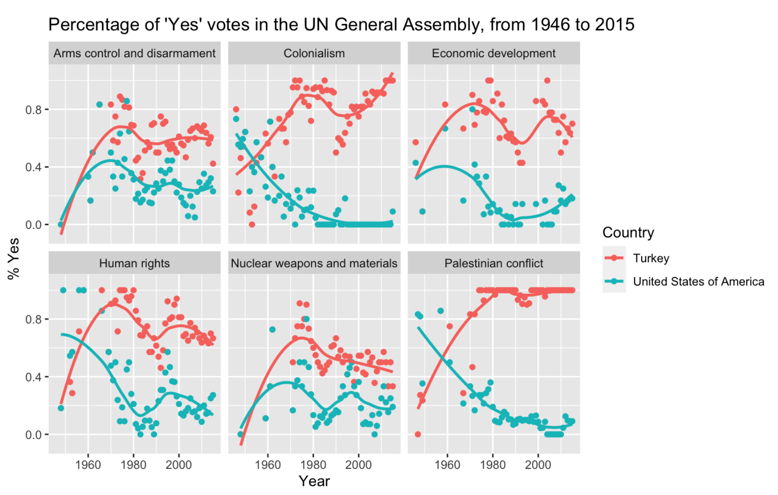

The six plots represented in this figure show categories of issues which the UN General Assembly has voted on each year from 1946 to 2015 and each color represents a nation (Either Turkey or the United States). The y-axis represents the proportion of ‘yes’ votes from each country and is plotted against the year in which they were made on the x-axis. Thus, each point on each graph represents the proportion of ‘yes’ votes for one of the two countries in a given year. The trend lines displayed for each country within each graph represent moving averages across time for proportions of ‘yes’ votes. These show larger trends in how the USA and Turkey have diverged on the various issues voted on in the UN over the last seven decades.